**Nama :** Aldo Dwie Rizky

**NPM :** 1193005

**Kelas :** D3 Teknik Informatika 3A

**Mata Kuliah :** Mobile Programming

Tugas Mobile Programming Membuat 4 Activity

1. SplassScreenActivity

Kode Program:

<?xml version="1.0" encoding="utf-8"?>  
<RelativeLayout  
 xmlns:android="http://schemas.android.com/apk/res/android"  
 android:layout_width="match_parent"  
 android:layout_height="match_parent"  
 android:orientation="vertical">  
  
 <ImageView  
 android:id="@+id/image"  
 android:layout_width="200dp"  
 android:layout_height="200dp"  
 android:layout_centerInParent="true"  
 android:src="@drawable/logo" />  
  
 <ProgressBar  
 android:id="@+id/loading"  
 android:layout_width="wrap_content"  
 android:layout_height="wrap_content"  
 android:layout_below="@+id/image"  
 android:layout_centerHorizontal="true"  
 android:layout_marginTop="50dp" />  
  
 <TextView  
 android:layout_marginBottom="16dp"  
 android:layout_alignParentBottom="true"  
 android:layout_centerHorizontal="true"  
 android:layout_width="wrap_content"  
 android:layout_height="wrap_content"  
 android:textStyle="bold"  
 android:text="Aldo Dwie Rizky (1193005)"/>  
  
</RelativeLayout>

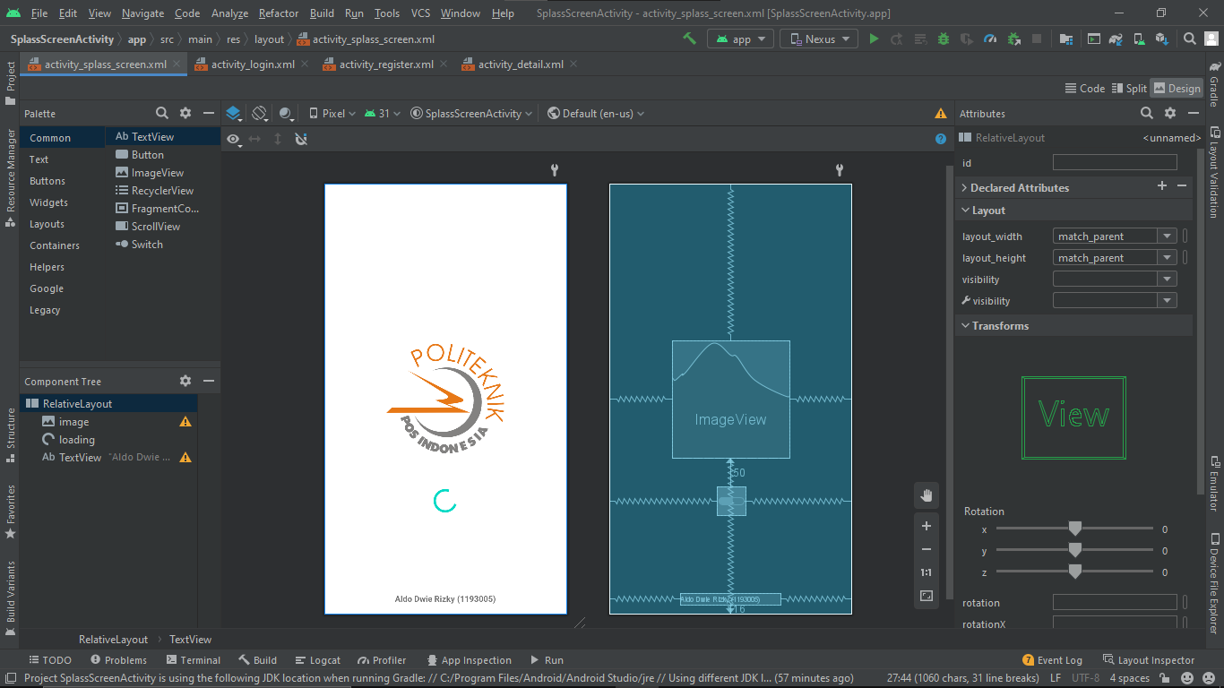Hasil:

1. LoginActivity

Kode Program:

<?xml version="1.0" encoding="utf-8"?>  
<!--suppress AndroidUnresolvableTag -->  
<LinearLayout xmlns:android="http://schemas.android.com/apk/res/android"  
 xmlns:app="http://schemas.android.com/apk/res-auto"  
 xmlns:tools="http://schemas.android.com/tools"  
 android:layout_width="match_parent"  
 android:layout_height="match_parent"  
 android:orientation="vertical"  
 android:padding="20dp"  
 tools:context=".MainActivity">  
  
 <!--suppress AndroidUnresolvableTag -->  
 <ImageView  
 android:layout_gravity="center_horizontal"  
 android:layout_height="100dp"  
 android:layout_marginBottom="25dp"  
 android:layout_width="match_parent"  
 android:src="@drawable/logo"/>  
  
 <TextView  
 android:layout_marginBottom="5dp"  
 android:layout_width="match_parent"  
 android:layout_height="wrap_content"  
 android:text="LOGIN"  
 android:textSize="20sp"  
 android:textStyle="bold"  
 android:textAlignment="center"/>  
  
"  
 <!--suppress AndroidUnresolvableTag -->  
 <com.google.android.material.textfield.TextInputLayout  
 android:layout_width="match_parent"  
 android:layout_height="wrap_content"/>  
 <EditText  
 android:layout_width="match_parent"  
 android:layout_height="wrap_content"  
 android:hint="Email"  
 android:inputType="textEmailAddress"/>  
  
 <com.google.android.material.textfield.TextInputLayout  
 android:layout_width="match_parent"  
 android:layout_height="wrap_content"/>  
 <EditText  
 android:layout_width="match_parent"  
 android:layout_height="wrap_content"  
 android:layout_marginTop="10dp"  
 android:hint="Password"  
 android:inputType="textPassword"/>  
  
 <Button  
 android:layout_width="match_parent"  
 android:layout_height="wrap_content"  
 android:layout_marginTop="20dp"  
 android:text="Masuk"/>  
  
</LinearLayout>

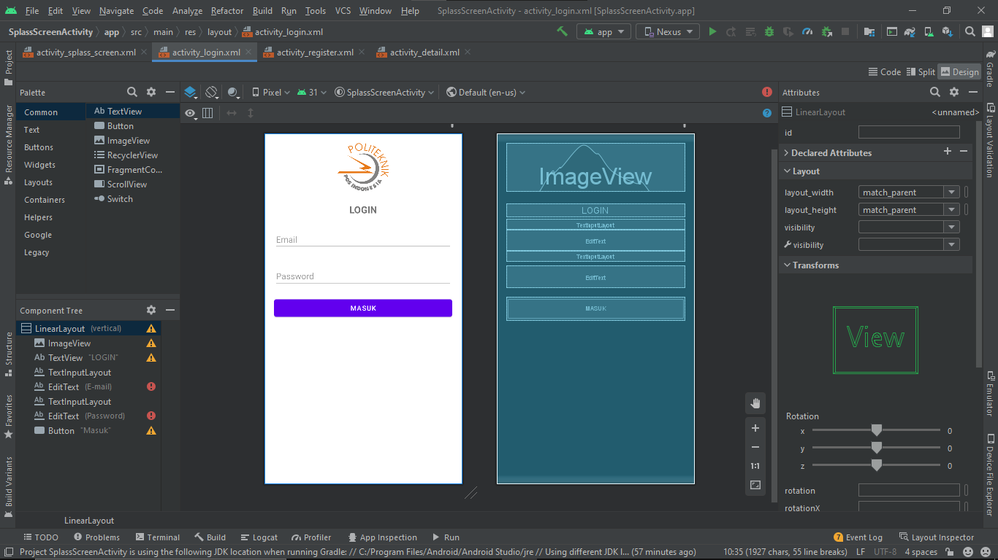Hasil:

1. RegisterActivity

Kode Program:

<?xml version="1.0" encoding="utf-8"?>  
<LinearLayout xmlns:android="http://schemas.android.com/apk/res/android"  
 android:orientation="vertical" android:layout_width="match_parent"  
 android:layout_margin="20dp"  
 android:layout_height="match_parent">  
  
 <LinearLayout  
 android:layout_width="match_parent"  
 android:layout_height="match_parent"  
 android:orientation="vertical">  
  
 <LinearLayout  
 android:layout_width="match_parent"  
 android:layout_height="wrap_content"  
 android:background="#ff0000">  
  
 <TextView  
 android:layout_width="match_parent"  
 android:layout_height="wrap_content"  
 android:layout_marginBottom="10dp"  
 android:layout_marginTop="10dp"  
 android:text="FORM PENDAFTARAN"  
 android:textAlignment="center"  
 android:textColor="#fff"  
 android:textStyle="bold" />  
 </LinearLayout>  
  
 <ScrollView  
 android:layout_width="match_parent"  
 android:layout_height="match_parent">  
 <LinearLayout  
 android:layout_width="match_parent"  
 android:layout_height="wrap_content"  
 android:layout_marginLeft="5dp"  
 android:layout_marginRight="5dp"  
 android:orientation="vertical">  
  
 <TextView  
 android:layout_width="match_parent"  
 android:layout_height="wrap_content"/>  
  
 <EditText  
 android:id="@+id/isiusername"  
 android:layout_width="match_parent"  
 android:layout_height="wrap_content"  
 android:layout_margin="5dp"  
 android:hint="Username" />  
  
 <EditText  
 android:id="@+id/isinamadepan"  
 android:layout_width="match_parent"  
 android:layout_height="wrap_content"  
 android:layout_margin="5dp"  
 android:hint="Nama Depan" />  
  
 <EditText  
 android:id="@+id/isinamabelakang"  
 android:layout_width="match_parent"  
 android:layout_height="wrap_content"  
 android:layout_margin="5dp"  
 android:hint="Nama Belakang" />  
  
 <TextView  
 android:layout_width="match_parent"  
 android:layout_height="wrap_content"  
 android:layout_margin="5dp"  
 android:text="Jenis Kelamin\t:" />  
  
  
 <RadioGroup  
 android:layout_width="match_parent"  
 android:id="@+id/jk"  
 android:orientation="horizontal"  
 android:layout_marginLeft="50dp"  
 android:layout_height="wrap_content">  
 <RadioButton  
 android:layout_width="wrap_content"  
 android:layout_height="wrap_content"  
 android:text="Laki - laki" />  
  
 <RadioButton  
 android:layout_width="wrap_content"  
 android:layout_height="wrap_content"  
 android:text="Perempuan" />  
 </RadioGroup>  
  
 <EditText  
 android:id="@+id/isipassword"  
 android:layout_width="match_parent"  
 android:layout_height="wrap_content"  
 android:layout_margin="5dp"  
 android:hint="Password" />  
  
 <EditText  
 android:id="@+id/isiemail"  
 android:layout_width="match_parent"  
 android:layout_height="wrap_content"  
 android:layout_margin="5dp"  
 android:hint="Email" />  
  
 <EditText  
 android:id="@+id/isialamat"  
 android:layout_width="match_parent"  
 android:layout_height="wrap_content"  
 android:layout_margin="5dp"  
 android:hint="Alamat" />  
  
 <EditText  
 android:id="@+id/isitelpon"  
 android:layout_width="match_parent"  
 android:layout_height="wrap_content"  
 android:layout_margin="5dp"  
 android:hint="Telpon" />  
  
 <TextView  
 android:layout_width="match_parent"  
 android:layout_height="wrap_content"  
 android:layout_margin="5dp"  
 android:text="Hobi\t:" />  
  
 <LinearLayout  
 android:layout_width="match_parent"  
 android:layout_height="wrap_content"  
 android:orientation="horizontal">  
  
 <CheckBox  
 android:id="@+id/melukis"  
 android:layout_width="wrap_content"  
 android:layout_height="wrap_content"  
 android:text="Melukis" />  
  
 <CheckBox  
 android:id="@+id/olahraga"  
 android:layout_width="wrap_content"  
 android:layout_height="wrap_content"  
 android:layout_marginLeft="72dp"  
 android:text="Olahraga" />  
 </LinearLayout>  
  
 <LinearLayout  
 android:layout_width="match_parent"  
 android:layout_height="wrap_content"  
 android:orientation="horizontal">  
  
 <CheckBox  
 android:id="@+id/membaca"  
 android:layout_width="wrap_content"  
 android:layout_height="wrap_content"  
 android:text="Membaca" />  
  
 <CheckBox  
 android:id="@+id/game"  
 android:layout_width="wrap_content"  
 android:layout_height="wrap_content"  
 android:layout_marginLeft="59dp"  
 android:text="Main Game" />  
 </LinearLayout>  
  
 <LinearLayout  
 android:layout_width="match_parent"  
 android:layout_height="wrap_content"  
 android:orientation="horizontal">  
  
 <CheckBox  
 android:id="@+id/Jalan"  
 android:layout_width="wrap_content"  
 android:layout_height="wrap_content"  
 android:text="Jalan Jalan" />  
  
 <CheckBox  
 android:id="@+id/musik"  
 android:layout_width="wrap_content"  
 android:layout_height="wrap_content"  
 android:layout_marginLeft="50dp"  
 android:text="Musik" />  
 </LinearLayout>  
  
 <Button  
 android:id="@+id/simpan"  
 android:layout_width="match_parent"  
 android:layout_height="wrap_content"  
 android:layout_margin="5dp"  
 android:text="Daftar" />  
 </LinearLayout>  
 </ScrollView>  
 </LinearLayout>  
</LinearLayout>

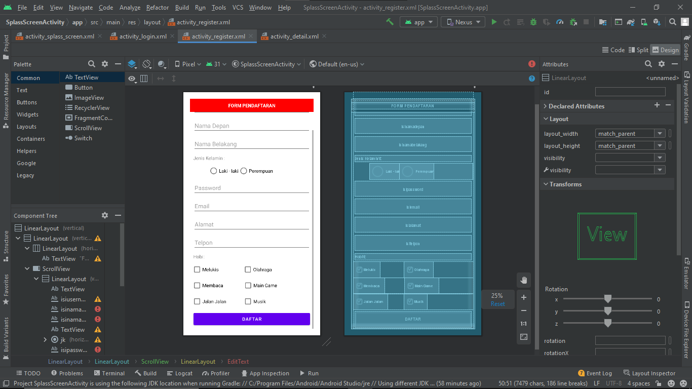Hasil:

1. DetailActivity

Kode Program:

<?xml version="1.0" encoding="utf-8"?>  
<LinearLayout xmlns:android="http://schemas.android.com/apk/res/android"  
 xmlns:app="http://schemas.android.com/apk/res-auto"  
 xmlns:tools="http://schemas.android.com/tools"  
 android:layout_width="match_parent"  
 android:layout_height="match_parent"  
 android:orientation="vertical"  
 tools:context=".MainActivity">  
  
 <ImageView  
 android:id="@+id/imageView"  
 android:layout_width="match_parent"  
 android:layout_height="wrap_content"  
 android:layout_marginLeft="10dp"  
 android:layout_marginRight="10dp"  
 android:layout_marginTop="10dp"  
 android:layout_marginBottom="25dp"  
 tools:srcCompat="@tools:sample/avatars" />  
  
 <TextView  
 android:layout_width="match_parent"  
 android:layout_height="23dp"  
 android:layout_marginLeft="10dp"  
 android:layout_marginRight="10dp"  
 android:layout_marginTop="25dp"  
 android:layout_marginBottom="20dp"  
 android:textSize="20dp"  
 android:textStyle="bold"  
 android:text="Aldo Dwie Rizky"  
 android:textAlignment="center" />  
  
 <LinearLayout  
 android:layout_width="355dp"  
 android:layout_height="wrap_content"  
 android:layout_gravity="center"  
 android:orientation="vertical">  
  
 <LinearLayout  
 android:layout_width="wrap_content"  
 android:layout_height="wrap_content"  
 android:layout_marginLeft="10dp"  
 android:layout_marginRight="10dp"  
 android:layout_marginTop="1dp"  
 android:layout_marginBottom="1dp"  
 android:orientation="horizontal">  
  
 <ImageView  
 android:id="@+id/imageView2"  
 android:layout_width="match_parent"  
 android:layout_height="wrap_content"  
 android:layout_marginRight="10dp"  
 app:srcCompat="@android:drawable/ic_dialog_map" />  
  
 <TextView  
 android:layout_width="match_parent"  
 android:layout_height="23dp"  
 android:textSize="20dp"  
 android:text="KP KS Tubun Asrama Brimob"  
 android:textAlignment="center" />  
 </LinearLayout>  
  
 <LinearLayout  
 android:layout_width="wrap_content"  
 android:layout_height="wrap_content"  
 android:layout_marginLeft="10dp"  
 android:layout_marginRight="10dp"  
 android:layout_marginTop="1dp"  
 android:layout_marginBottom="1dp"  
 android:orientation="horizontal">  
 <ImageView  
 android:id="@+id/imageView5"  
 android:layout_width="match_parent"  
 android:layout_height="wrap_content"  
 android:layout_marginRight="10dp"  
 app:srcCompat="@android:drawable/ic_dialog_email" />  
  
  
 <TextView  
 android:layout_width="match_parent"  
 android:layout_height="23dp"  
 android:textSize="20dp"  
 android:text="aldodwrzy@gmail.com"  
 android:textAlignment="center" />  
  
 </LinearLayout>  
 <LinearLayout  
 android:layout_width="wrap_content"  
 android:layout_height="wrap_content"  
 android:layout_marginLeft="10dp"  
 android:layout_marginRight="10dp"  
 android:layout_marginTop="1dp"  
 android:layout_marginBottom="1dp"  
 android:orientation="horizontal">  
  
 <ImageView  
 android:id="@+id/imageView4"  
 android:layout_width="32dp"  
 android:layout_height="match_parent"  
 android:layout_marginRight="10dp"  
 app:srcCompat="@android:drawable/stat_sys_vp_phone_call" />  
  
  
 <TextView  
 android:layout_width="match_parent"  
 android:layout_height="23dp"  
 android:textSize="20dp"  
 android:text="08996136751"  
 android:textAlignment="center" />  
  
 </LinearLayout>  
  
 </LinearLayout>  
  
 <TextView  
 android:layout_width="match_parent"  
 android:layout_height="wrap_content"  
 android:text="Laki-Laki"  
 android:layout_marginLeft="25dp"  
 />  
  
 <TextView  
 android:layout_width="match_parent"  
 android:layout_height="23dp"  
 android:layout_marginLeft="25dp"  
 android:text="Hobi : Futsal" />  
</LinearLayout>

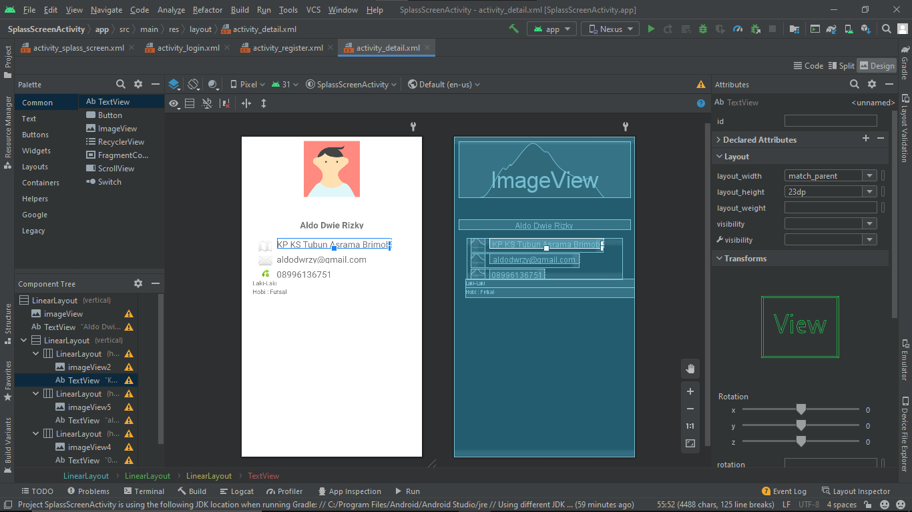Hasil: